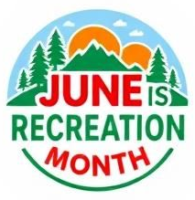
[Organization/Region Letterhead or Logo]
FOR IMMEDIATE RELEASE
Date: [Insert Date]
[Headline]
[Highlight]
[City, Province] – [Organization Name] is excited to announce its participation in June is Recreation Month, taking place throughout [month/year]. This annual initiative celebrates active living, community connection, and inclusive recreation opportunities for people of all ages and abilities.
Event Highlights:
- Week 1 – Bike Week: [Brief description of activities, e.g., “Explore local trails and join guided rides for all skill levels.”]
- Week 2 – Inclusive Recreation Week: [Brief description, e.g., “Try adaptive and accessible recreation activities designed for everyone.”]
- Week 3 – Connecting with the Land Week: [Brief description, e.g., “Outdoor programs, nature walks, and environmental exploration.”]
- Week 4 – Explore Your Community Week: [Brief description, e.g., “Community scavenger hunts, pop-up play zones, and local park adventures.”]
“[Quote]”
Participation & Registration:
About June is Recreation Month:
June is Recreation Month is a province-wide celebration of active living, fun, and community connection across Nova Scotia. Communities work together to offer inclusive activities for all ages and abilities, encouraging people to get outside, try something new, and connect locally. Together, these efforts highlight how accessible recreation and social connection help build healthier, stronger communities.
Media Contact:
[Name]
[Title/Role]
[Organization]
[Email]
[Phone]

