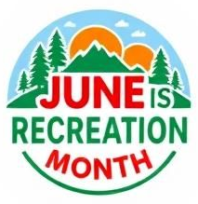

[Your Organization’s Name]
[Address]
[City, Province, Postal Code]
[Date]
[Company Name]
[Address]
[City, Province, Postal Code]
Dear [Sponsor Name],
On behalf of [Your Organization/Event Name], I am reaching out to request your support through the donation of items that will directly benefit June is Recreation Month.
June is Recreation Month is a coordinated, province-wide celebration designed to promote the importance of physical activity, recreation, and community connection. The initiative provides communities, municipalities, and recreation departments with a shared platform to highlight programs, strengthen partnerships, and inspire residents to participate in local recreation opportunities.
We kindly request items that support recreation and leisure activities within our community. These donations will be used to [raffle off, distribute to participants, etc.], helping ensure the success of our initiative and extending our reach within the community. We are committed to highlighting the generosity of our partners and strengthening relationships within the community.
We would be grateful to receive your donated items by [deadline], if possible. I would be happy to arrange pickup at your convenience or provide any additional information you may need.
Thank you for considering this request and for your commitment to supporting our community. We truly appreciate your time and generosity.
Warm regards,
[Your Name]
[Your Title/Role]
[Your Organization]
[Contact Information]

